STRENGTHENING COMMUNITY CHARACTER AND LITERATURE IN HANDLING STUNTING THROUGH VILLAGE DIGITALIZATION IN GUWOSARI SUB-DISTRICT
An-Nisa Apriani¹, Kana Safrina Rouzi², Mufida Awalia Putri^{3*}, Yhona Paratmanitya⁴, Defia Ifsantin Maula⁵, Endi Rohaendy⁶, Sukati⁷, Laelatul Badriah⁸, Dadang Heksaputra⁹, Rizky Saputri¹⁰
^{1,6}Program Studi PGSD
^{2,3,7,8,10}Program Studi PGMI
⁴Program Studi Gizi
⁵Program Studi Manajemen
⁹Program Studi SI
Universitas Alma Ata, Indonesia
*Co-Author: mufida.awalia@almaata.ac.id

ABSTRACT. TPA cadres' understanding toward the role of Quran literacy, Living Values Education Program (LVEP), business & economy and literacy digitization in stunting handling is still inadequate. Strengthening their literacy in handling stunting is needed to prevent stunting problems in the TPA environment. This community service activities aim to increase the understanding of TPA cadres pertainin the Quran literacy, LVEP, business, economics, and digitalization as one of the programs to strengthen community literacy in stunting control. The main activity of the workshop is in the form of training using the lecture method, question and answer, and discussion. The community service activities are carried out through three stages, namely preparation, implementation, and evaluation. The participation and enthusiasm of the TPA cadres in the activity was very good, the partner group contributed actively in the workshops on strengthening community character and literacy in handling stunting through village digitization in the Guwosari sub-district.
______________________
Keyword: Character Building;, Literacy; Stunting; and digitization

INTRODUCTION
Stunting is a condition of chronic malnutrition, especially in the First 1000 Days of Life (HPK), which often occurs in developing countries. Stunting is widely risked in children who are susceptible to disease to reduce productivity as adults. Handling stunting must be carried out in a multi-sectoral manner, such as socio-economic, education, health, agriculture, environment, sanitation, and meeting other basic social needs. Universities play an important role in contributing to reducing stunting rates. Alma Ata University took the initiative to implement the Tri Dharma of Higher Education through collaborative learning activities in the field as a form of implementation of Merdeka Belajar Kampus Merdeka (MBKM) in the Stunting Care (PENTING) student program.
Community empowerment was carried out in Guwosari District based on the best research results from the university with the title "Optimizing Guwosari Local Potential as an Effort to Build Independent Villages and Care for Stunting". This program aims to comprehensively address the stunting problem faced by the Guwosari community in collaboration with the Faculties of Health, Economics, Informatics, and Education, Alma Ata University through a literacy culture in the community which includes activities such as: (a) reading literacy, (b) numeracy literacy, (c) scientific literacy, (d) digital literacy, (e) financial literacy (f) character literacy and (g) Quran literacy. Research results that support the literacy program show that digital literacy skills are very low so it takes a lot of effort to optimize these skills, one best way is to increase digital literacy skills (Perdana, R., Yani, R., Jumadi, J., & Rosana, 2019). Based on the literacy culture in the community, following list is urgently needed, 1) understanding literacy and stunting, 2) Life Values Education Program (LVEP) literacy, 3) understanding the importance of literacy in stunting management through LVEP literacy, 4) understanding stunting handling. Based on the research results of the universities in the field of education, it was found that the cultivation of the character of nationalism with sub-character of nationalism in the Living Values Education Program (LVEP) was observed during the thematic learning process, namely responsibility, tolerance, cooperation, unity, love, respect, and peace (Apriani, A. N., Sari, I. P., & Suwandi, 2017) (Putri et al., 2022). The results of other educational studies show that the use of LVEP in learning activities can increase understanding of anti-radicalism, namely citizenship, compassion, courtesy, justice, moderation, respect for others, respect for creators, self-control, and tolerance(A. Apriani, 2019).
Through LVEP, it is hoped that TPA cadres and TPA children can understand, feel, and apply these values in their lives. It is hoped that these can support the stunting prevention programs. Consuming healthy and nutritious food in collaboration between TPA cadres and parents is also hopefully can meet the their nutritional needs. The TPA cadres' love for children will become the trigger to remind them to provide healthy nutrition. Those are some examples of LVEP value activities related to healthy and nutritious food. Based on the description above, it can be concluded that the education factor that has the potential to reduce malnutrition in children and toddlers (stunting) will be overcome.
The purpose of this community partnership are (1) Increasing the acceleration of the realization of literary culture in the community (2) Significantly increasing community participation in the National Literacy Movement (3) Increasing public literacy about stunting and how to handle it, (4) Providing a collection of reading books/libraries and literacy culture that can be utilized optimally and effectively by the community (5) Providing means to access cheaper information technology/internet services (6) Facilitating education and skills training in life values education programs in community empowerment and job development.
METHOD
The method of socialization, training, and mentoring of community character and literacy strengthening programs in dealing with stunting through village digitization includes several stages as follows:
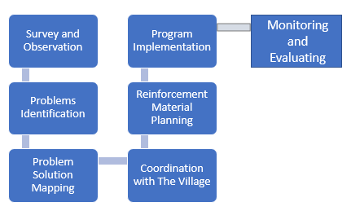
Figure 1. Community Empowerment Implementation Methods
The first stage was to conduct a survey and observation of the literacy problems of the village community and then identify the literacy problems of the village community. The team then mapped out solutions to these problems, namely strengthening rural community literacy which includes Al-Qur'an literacy, Living values education program in dealing with stunting, E-library literacy, and business literacy. Next, coordinating with the village government to determine when we carry out community service programs.
The Second is the planning of mentoring training materials that are able to anticipate the demands of future development needs and strengthen community participation, through a destine management organization approach to develop the quality of literacy digitalization organization that can empower rural communities.
The next stage is program implementation by providing training and mentoring for the community on Qur'an literacy, Living values education programs in stunting handling, business literacy, and literacy digitization (E-Library). The method used in that stages were lecture, discussion, and question and answer method. The training and mentoring were held in order to explore the values of the Qur’an, LVEP, e-library, and business literacy aimed at preventing and dealing with stunting problems in Guwosari village.
The last stage is the team to evaluate the implementation of training and mentoring which aimed to find out the results of service through the Guwosari community's response to programs that have been implemented.

RESULT
This community services were held offline with the strict health protocol implemented. The participants of this activity were 40 TPA teachers/cadres in Kelurahan Guwosari.

Preparation
Implementers of community service activities (PkM) in Guwosari Village consist of 3 lecturers from the PGSD Study Program, 3 lecturers from the PGMI Study Program, 1 lecturer from the Nutrition Study Program, 1 lecturer from the Management Study Program and 1 lecturer from the Informatics Study Program, 1 lecturer from Islamic Studies Program and assisted by students. In Implementing PkM activities are assisted by two PGSD students who master the LVEP concept and 1 student from the nutrition study program who master the stunting concept and 1 PGMI student who understands the TPA curriculum. The student serves as a lecturer assistant in the implementation of PkM. This activity can be used as a provision so that they have a meaningful experience which leads to articles that are ready to be published in national journals. These various series of PkM activities are expected to increase the understanding of the TPA cadres of the Guwosari sub-district about LVEP as a strategy in dealing with the stunting problem in the village.
Prior to the implementation of the PkM, the implementing team carried out several preparations such as; coordination between LP2M UAA and the Guwosari village, coordination of the PkM team with the mosque/TPA cadres who will become community service participants, and materials and modules to support training activities preparation. During the direct coordination, we conducted observations and interviews to find out the real conditions regarding stunting management strategies among TPA cadres/Iqro’ and Quran teachers in the village. Based on the observations and interviews, it can be concluded that the literacy of stunting management strategies for some TPA cadres are still minimal, then the training for TPA cadres on LVEP literacy in handling stunting is needed.
This PkM activity is in the form of training which was carried out in 2 sessions at Guwosari village training center. LVEP literacy in stunting held on December 22-23 2021. Each session of training activities lasts 120-180 minutes.

Implementation
Al-Qur'an Learning Mentoring Program (Al-Qur'an Literacy)
Community assistance in learning Al-Qur'an literacy which is carried out in Guwosari Village is a training that includes a study of the Qur'an Learning curriculum in the form of discussing the teaching matrix of the Al-Qur'an Education Park (TPA). The Al-Quran Literacy Program was held on December 20-21, 2021 at the Guwosari village hall. This matrix is divided over two days. On the first day, the use of the book Iqra' volumes 1-6 by As'ad Humam (1990)(As’ad Humam, 1990). In this first meeting, direct practice was carried out with the Iqra’ tashih reading method, memorizing prayer readings and short Surah. The next session was worship practices which included the practice of ablution as well as daily prayers and etiquette. The end of the session was filled with Tahsinul Kitabah and direct practice was carried out.
On the second day, the introduction to Tajweed and practiced in reading selected verses, namely: QS. Al Baqarah: 255, 284-285, Ali Imran: 133-136, Al Mu'minun: 1-11, and Al Luqman:12-15. The goal is that when you become an Imam, you will be able to read the readings in prayer smoothly because the mentor reads directly in front of the participants. The next session was an introduction to the basics of dinul Islam which included the pillars of faith, the pillars of Islam, Asmaul Husna, and the story of the Prophet Ulul Azmi. In the last session, the training materials were in the form of local content and self-development in the form of practices of Hadrah, Qasidah, Nasyid, Self-Defense, and Foreign Languages (English and Arabic).

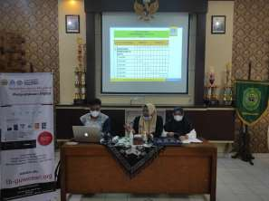
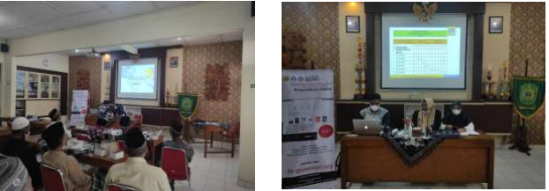
Figure 2. Presentation of Al-Quran literacy material to the TPA Cadres

Literacy Living Values Education Program in handling stunting in Guwosari Village
Literacy related to stunting also needs to be improved for cadres. They also play a role in disseminating and integrating information related to stunting and its prevention efforts to the wider community included the TPA students. Stunting literacy was carried out on December 22, 2021 at the Guwosari village hall. This educational program is carried out with a duration of 120 minutes consisting of the delivery of material by the Lecturer of the Undergraduate Nutrition Study Program, Dr. Yhona Paramanatiya, S.Gz, followed by a discussion/question-and-answer session. The material provided includes the definition of stunting, the causes of stunting, how to identify stunting conditions, and how to identify stunting prevention efforts. Participants were very enthusiastic about this educational activity, indicated by the many questions asked in the question and answer session. They stated that they gained new knowledge about stunting and were ready to disseminate information to the community around Guwosari Village.
The first session, the implementation of PkM begins with the delivery of literacy materials, character education concepts, and character literacy materials about stunting. Literacy material was delivered by Ruwet Rusiyono, M.Pd. Meanwhile, the material for character and character literacy on stunting was delivered by Mufida Awalia Putri, M.Pd. Submission of the material aims to make participants understand that stunting handling can be carried out in the TPA scope with character integration to children as the main subject of the stunting handling.
The second session is the delivery of character literacy integration materials to deal with stunting in the TPA curriculum. The material was delivered by Sukati, M.Pd. The delivery of the material aims to gain participants understanding of how to deal with stunting in TPA activities through a stunting character literacy strategy.
The third session, delivery of material on the concept of LVEP and literacy in the handling of stunting through the LVEP strategy. The material was delivered by An-Nisa Apriani, M.Pd. The delivery of the material aims to give participants a broader understanding of stunting handling through the LVEP strategy.
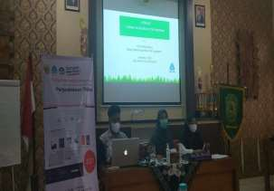
Figure 3. Presentation of LVEP literacy material to the TPA Cadres
Business Literacy & Entrepreneurship
The next community service activity is the delivery of material related to business literacy and entrepreneurship delivered by Defia Ifsantin Maula, SIP, MBA. The material presented includes the concept of entrepreneurship, entrepreneurial characteristics, advantages and disadvantages of entrepreneurship, building an entrepreneurial mindset, and making business plans for the environment family. Entrepreneurial families are expected to be able to more economically empowered so that they can contribute to reducing the stunting rate in Guwosari village starting from the family environment. Thus strengthening business literacy programs in the field of business & entrepreneurship with the aim of empowering the family economy are believed to be able to support the reduction of stunting prevalence, due to the following factors: business & entrepreneurship can affect the education level of family food security, access to health services, and environmental sanitation.

Digitization of Literacy
Literacy digitization program through library information system can facilitate access anywhere and anytime. The development of library information system features includes bibliography, circulation, membership, master file, stock take, system, reporting, and serial control. The bibliography module manages bibliographies/catalogs and item databases/copies. Circulation module to circulate library goods such as borrowing and returning. The membership module manages library membership. The master file module manages reference data to be used by other modules. The stocktake module performs the library stock management process. The system module configures system, user, and backup behavior. The reporting module maintains dynamic, real-time reports on library collections and circulation. The serial control module performs control management of the host system configuration. Figure 4 shows the system home page library information. This page is displayed to all residents so that library members/non-library members can review the digital literacy collection in Guwosari Village.
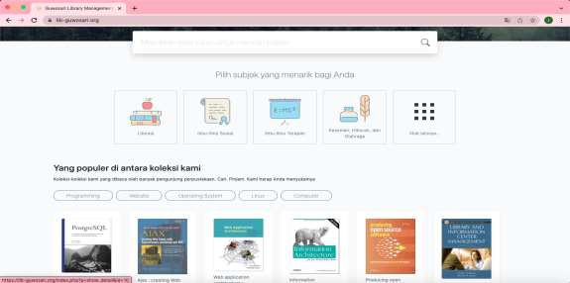
Figure 4. Homepage

Figure. 5 shows Shows detailed information on digital literacy collections. This information displays the biodata/identity of the selected digital literacy. Identity includes series title, publisher, media type, isbn, brief description of literacy, and other variables.

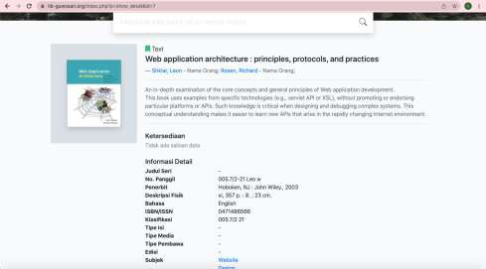
Figure 5. Book/Digital Literacy Information Detail Page

Figure 6 is an administrator page to perform data management of the entire library information system management.

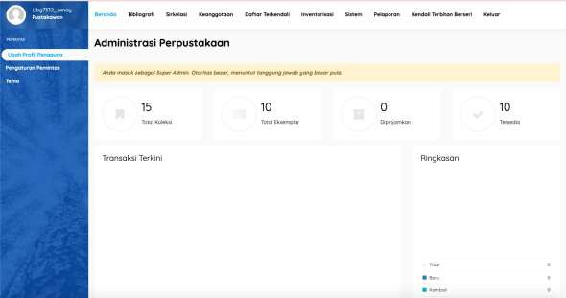

Figure 6. Administrator Page

Figure 7 shows the catalog settings page on the library information system. Catalog settings set all the attributes of the digital literacy identity.
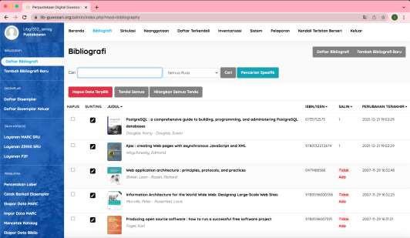
Figure 7. Catalog Settings Page

DISCUSSION
The targets of Al-Qur'an Literacy are TPA managers because it is from these TPA teachers that the spread of learning to read the Qur'an begins. Learning the Qur'an must be started at the early age because reading the Qur'an is a basic skill for Muslims to have the ability to understand the contents of the Qur'an(Sadiyah, K., & Kholili, 2021). This training begins with learning the book of Iqra 'which starts with basic knowledge whose reading consists of two or three letters so that you can finally read one verse. Furthermore, in this training the TPA teachers were also assisted to teach tahfiz to children so that the reading of the makharizul letters is correct. This is in accordance with research from Ningrum (2020)(Ningrum, A. P., Dewi, N. A., Apriyanti, I., & Tambunan, 2020) who concluded that reading the Qur'an and learning how to read and write the Qur'an in accordance with good and valid rules are important requirements that must be mastered to know the meaning of the verses of the Qur'an.
This assistance is not only in iqra' learning but also provides training related to worship practices, daily prayers and the introduction of the Islamic religion. This is intended so that learning at the TPA is thorough and makes TPA students able to gain knowledge of the Qur'an and its application in worship practices and other muamalah activities. With this assistance, it is hoped that the Guwosari TPA manager can maximize the function of the TPA which is not only a center for learning to read the Koran but also as an Islamic character development that covers all aspects of children's lives(Retnasari, L., Suyitno, S., & Hidayah, 2019).
Furthermore, the implementation of community service with the topic of literacy in stunting handling through LVEP provides benefits for community service participants, especially for TPA cadres who are tasked with educating children to become human beings with noble character in accordance with the Qur'an. Values of living physically and mentally healthy without any indication of stunting in children. In addition, the condition of healthy children without indications of stunting can help millennial children understand, feel, and live the values of LVEP in diversity/difference to support the formation of a multicultural Indonesian nationalist character. a country that upholds the values of unity, peace, respect, love and tolerance. This is consistent with the results of research showing that LVEP is able to increase several universal values such as the values of responsibility, tolerance, cooperation, unity, love, respect, and peace in thematic learning(Apriani, A. N., Sari, I. P., & Suwandi, 2017). Furthermore, implementation stunting through LVEP can also form TPA cadres who have universal values attached and uphold good values such as the values of tolerance, cooperation, peace, and respect. This is also supported by research results which show that LVEP is able to increase several good values such as citizenship, compassion, courtesy, fairness, moderation, respect for other, respect for creators, self-control, and tolerance(A. N. Apriani, 2019). Thus, community service activities with the integration of LVEP in the handling of stunting not only form good characters for children but also the character of TPA cadres to become educators who love peace, have good tolerance with others and children, have good cooperation with other cadres, and make children have good morals. Literacy related to stunting also needs to be improved for TPA teachers. Previous research has suggested that community leaders or religious leaders can be named and participate in disseminating health information. They can play a role in disseminating information related to stunting to the public in general, as well as integrating understanding about stunting and its prevention efforts in the learning process in TPA students. In this training, the material related to stunting provided includes the definition of stunting, the causes of stunting, how to identify stunting conditions, and stunting prevention efforts.
Strengthening in the economic field also needs to be conveyed to TPA cadres so that economic empowerment starts from the family in handling stunting. It is hoped that economically more empowered families can contribute to reducing stunting rates. Previous research has also stated that the socioeconomic status of the family is one of the factors that determine the amount of food available in the family, including influencing the growth and development of children and playing a role in preventing stunting problems(Citrakesumasari, C., Susilowati, D., Suriah, S., & Bohari, 2012).
Digital literacy (online library) is also important to convey to TPA cadres. Libraries are an important element in the world of education by collaborating library services with technology. The development of digital libraries improves the process of library services with good quality and speed, as well as increasing the effectiveness and efficiency of library management as a means of teaching and learning for the community(Ibrahim, I. A., & Faramita, 2015). The application of digitization has a positive impact on rural communities in monitoring stunting handling using digital media with a maternal and child health surveillance approach(Heksaputra, D., Bahrudin, M. J. U. H., Fauziyah, A. K., & Wijaya, 2021). The application of library digitization pays attention to economic factors, flexibility, simplicity, and reliability that support user needs in the 4.0 industrial revolution.
CONCLUTION
Based on the results and discussion, it can be concluded that the socialization, training, and mentoring activities are able to increase the understanding of TPA cadres about Al-Quran literacy, Life Values Education Program, business & entrepreneurship, and digital. The Al-Quran literacy program helps TPA cadres have knowledge of Islamic religious values that are broad-minded, critical, creative, innovative, and dynamic in order to form a young generation that is healthy (not stunted), faithful, devoted, and pious. . Furthermore, in the stunting literacy program, TPA cadres play an important role in socializing related to stunting and its prevention to TPA students. Character literacy through LVEP contributes to TPA cadres who have universal values such as the values of love, peace, tolerance, cooperation, and responsibility as educators to assist the government in dealing with stunting problems as well as the literacy program on business and economics. Entrepreneurial activities from the family environment are believed to have a big role in handling stunting.

REERENCES
Apriani, A. N., Sari, I. P., & Suwandi, I. K. (2017). Pengaruh Living Values Education Program (LVEP) terhadap Penanaman Karakter Nasionalisme Siswa SD dalam Pembelajaran Tematik. Taman Cendekia: Jurnal Pendidikan Ke-SD-An, 1(2), 102–112.
Apriani, A. (2019). Pengaruh Living Values Education Program (LVEP) terhadap Penanaman Anti-radikalisme Siswa SD dalam Pembelajaran Tematik. LITERASI (Jurnal Ilmu Pendidikan), 10(2), 116–128. doi:http://dx.doi.org/10.21927/literasi
Apriani, A. N. (2019). Pengaruh Living Values Education Program (LVEP) terhadap Penanaman Anti-radikalisme Siswa SD dalam Pembelajaran Tematik. LITERASI (Jurnal Ilmu Pendidikan), 10(2), 116–128.
As’ad Humam. (1990). Buku Iqro’:Cara Cepat Belajar Menbaca Al-Qur’an. Balai Litbang LPTQ Nasional Team Tadarus “AMM” Yogyakarta.
Citrakesumasari, C., Susilowati, D., Suriah, S., & Bohari, B. (2012). Mappacci Sebagai Pendekatan Pemberian Pemahaman Calon Pengantin Tentang Anemia Gizi Dan Kurang Energi Kronik (KEK) Di Kabupaten Barru Sulawesi Selatan. MPPKI, 1(1), 25–31.
Heksaputra, D., Bahrudin, M. J. U. H., Fauziyah, A. K., & Wijaya, D. P. (2021). Analisis Antenatal Care (Anc) Pada Surveilans Kesehatan Ibu Dan Anak Dengan Tahapan Agregasi Pipeline NOSQL. IJUBI, 4(1), 16–24.
Ibrahim, I. A., & Faramita, R. (2015). Hubungan faktor sosial ekonomi keluarga dengan kejadian stunting anak usia 24-59 bulan di wilayah kerja puskesmas Barombong kota Makassar tahun 2014. Al- Sihah: The Public Health Science Journal, 7(1).
Ningrum, A. P., Dewi, N. A., Apriyanti, I., & Tambunan, R. R. (2020). Mengenal Pembelajaran Baca Tulis Alqur’an. Ihya Al-Arabiyah: Jurnal Pendidikan Bahasa Dan Sastra Arab, 6(1), 51–56.
Perdana, R., Yani, R., Jumadi, J., & Rosana, D. (2019). Assessing students’ digital literacy skill in senior high school Yogyakarta. JPI (Jurnal Pendidikan Indonesia), 8(2), 169–177.
Putri, M. A., Apriani, A., & Sari, I. P. (2022). Peningkatan Pemahaman Masyarakat Tentang LVEP Sebagai Program Penguatan Pendidikan Karakter di Kawasan Wisata Banjaran. 4(2), 48–54.
Retnasari, L., Suyitno, S., & Hidayah, Y. (2019). Penguatan Peran Taman Pendidikan Al-Quran (TPQ) Sebagai Pendidikan Karakter Religius. Jurnal Solma, 8(1), 32–38.
Sadiyah, K., & Kholili, S. A. (2021). Pendampingan Pembelajaran Baca Tulis Al Quran Pada Siswa SD Negeri 2 Kuwasen Jepara. Jurnal Pengabdian Masyarakat Multidisiplin, 4(3), 148–153.

